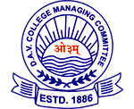**O.S.D.A.V.Public School, Kaithal**

**Term- I Exam (2024-25)**

**Subject : Social Science**

**Class : IV**

**Time:- hrs**. **M.M. 60**

**“General Instructions”**

a) All questions are compulsory.

b) Answer questions neatly and carefully.

**Name…………………..Roll No. …………………Section……………………….**

|  |  |  |
| --- | --- | --- |
| Q1 | **Fill in the blanks**:  **Society, adopted , Suspension , Ramadan , healthy , parents , joint, cement , gurudwara , breed**     1. Children develop a kind and caring attitude by watching their parents. 2. Suspension bridge can cover a long distance . 3. Clean surroundings help us to live healthy. 4. Adopted child is the permanent member of a family. 5. Flies and mosquitoes breed on the garbage . 6. Cement helps in making a building strong. 7. Anand Karaj takes place in gurudwara . 8. A joint family is made up of many nuclear families. 9. Ramadan is the long fasting month of the muslims . 10. A society is an organized group of people . | Marks  10×1/2 =5 |
| Q 2 | **Match Column (A) with Column (B) according to the correct answers.**  (A) (B)  1. Sunlight keeps the a) famous in Kerala 3  2. Doors and windows should have b) their grandparents 6  3. Kathakali dance c) germs away . 1  4. Bandra sea link bridge is in d) bolts and locks 2  5.Flats and bungalows are e) Maharashtra 4  6.Children share a special bond f) examples of permanent houses 5 | 6×1/2 =3 |
| Q 3 | **Choose the correct option**.    1. On which festival effigies of Ravana, Meghnadh and Kumbhakarna are burnt?  a) Holi √ b) Dusshera c) Navroz d) Onam  2. Quran is the holy book of the ....................... .  a) Sikhs. √ b) Muslims. c) Hindus. d) Christians  3. Which is the first school of a child?  a) museum √ b)family. c) port d) galaxy  4. Sharing home teaches us………………  a) Cooperation b)Living in harmony c) Caring behaviour √d) All of these  5 . Who invented Braille Script?  √ a). Louis Braille b) Adam Smith c) Edison d) Virat Kohli  6 . Earlier the suspension bridges were made of  a) Iron b) Cement c) Steel √d) Wood and rope  7. Navroz is celebrated by…………….  a) muslims √ b) Parsis c) Jains d) Hindus | 7×1=7 |
| Q 4 | **Write any four steps of the brick making process : -**  Mining  Brick making process  Tempering  Drying  Moulding | 4X1/2 =2 |
| Q 5 | **State whether the following statements are True or False :**   1. Family is the first school of a child. True 2. Participation is more important than winning. True 3. We should not throw garbage in the dustbin. False. 4. Bricks are made at a kiln . True 5. Always keep your things at proper places. True 6. Onam is the harvest festival of Haryana . False | 6X1/2 =3 |
| Q 6 | **Look at the given pictures and give answer accordingly :-**     1. **Identify the language used by hearing**   **impaired.**  **Sign Language**     1. **Name of the bridge :**   **Arch Bridge** | 1x2=2 |
| Q 7 | **Answer in one word :**  **1.** Write any one good point of your neighbourhood.    They do not waste water.  2. Give any one example of temporary house.  Hut, tent, stilt house etc.  3. Write any two good things that you have learnt from your family members.  Cooperation, living in harmony  4.Write any one feature of Navratri celebrations.  It is celebrated for nine nights.  5. Why do people move to different parts of the world?  For jobs , climate, education etc.  6 .What can be caused by open garbage bins?  Foul smell | 1x6=6 |
| Q 8 | **Answer the following questions in detail:**  1 .Write any two lessons that you can learn from Neerad &Ayesha`s story .  The two lessons are   1. Always keep your surroundings neat and clean. 2. Make compost of kitchen waste.   .  2. What is Sign language. ?    Sign language is an organized system of gestures or mime. It is used in place of speech by deaf people.  3. Differentiate between the lives of Lokhan and Ayaan .  1. Lokhan lives in a village but Ayaan lives in a city .  2. Ayaan has seen many modern bridges but Lokhan has not seen any.  4.Write any two benefits of modern building materials.  The benefits are:   1. They are not damaged by strong wind. 2. They are not flooded by rain.   5. Why is it important to help others?  It is important to help others so that we can make them happy and comfortable.  6.List any two dangers that can be posed by open garbage heaps.  The dangers are:   1. Many diseases are spread. 2. Flies and mosquitoes breed on the garbage.   7. What is a family ? Name two types of families .  A family is made of married couple and their children. Types of families nuclear family and joint family.  8.What is the importance of participating in school stage programmes?(any 2 points)  Participation in school stage programmes help us to:   1. Develop confidence 2. Discover new things   9.Mention the things children learn by watching the family members.  The children learn good behaviour, moral values and skills by watching their family members. | 2X9=18 |
| Q9 | Long- answer questions:-  1. Mention any three features of an ideal home.  The features are:  1. It should be well ventilated.  2. It should get plenty of sunlight .  3. It must have proper system of drainage, water supply and doors and windows .  2. What is a bridge? How is it useful?  A bridge is a structure that is built across river, mountain, valley etc.  It helps in the easy movement of people ,goods and vehicle.  3. How is Navroz celebrated in India ?  On Navroz the Parsis clean and decorate their home. The wear new clothes. They offer prayer in the fire temple. They wish Sal Mubarak to each other . They exchange gifts. They serve fresh fruits, dry fruits ,seeds ,etc. | 3X3=9 |
| Q 10 | Label the following states on a political map of India . 1. State of Golden bridge . Tamil Nadu  2. State in desert Rajasthan  3. State that celebrates Onam Kerala  4. Assam  5. State close to the sea. Kerala, Goa ,Maharashtra etc. | 1x5=5 |

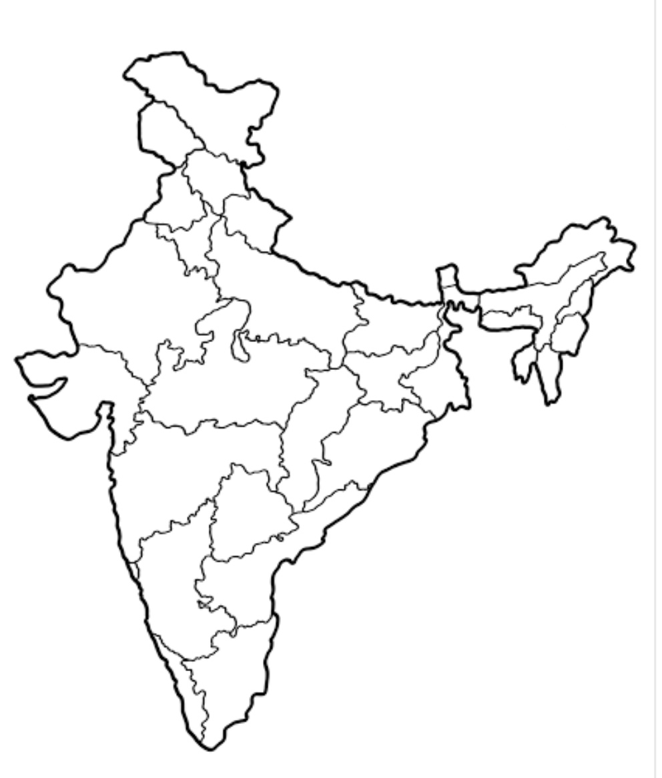

4. Assam

Rajasthan 2

3,5 Kerala

1. Tamil Nadu